**Shapley - 8 Features (FI 0.70)**

Considering Shapley Feature importance values ≥ 0.70.

**Features:** FC3, Fz, F7, FT7, T4, T3, Fp2, Fp1.

**Machine learning evaluation using 8 Features with Feature Importance ≥ 0.60.**

|  |  |  |  |  |  |  |
| --- | --- | --- | --- | --- | --- | --- |
| Model | Accuracy | Precision | Recall | F1-score | AUC-ROC | Training Times (s) |
| KNN | 0.967139 | 0.975713 | 0.958100 | 0.966826 | 0.967135 | 1.43 |
| Random Forest | 0.944652 | 0.960231 | 0.927681 | 0.943675 | 0.944645 | 240.14 |
| XGBoost | 0.820562 | 0.844374 | 0.785812 | 0.814041 | 0.820548 | 4.09 |
| Decision Tree | 0.853255 | 0.856115 | 0.849099 | 0.852593 | 0.853254 | 13.98 |
| Extra Trees | 0.947936 | 0.970331 | 0.924086 | 0.946644 | 0.947927 | 87.94 |

**Table:** Machine learning evaluation using 8 Features with Feature Importance ≥ 0.70.

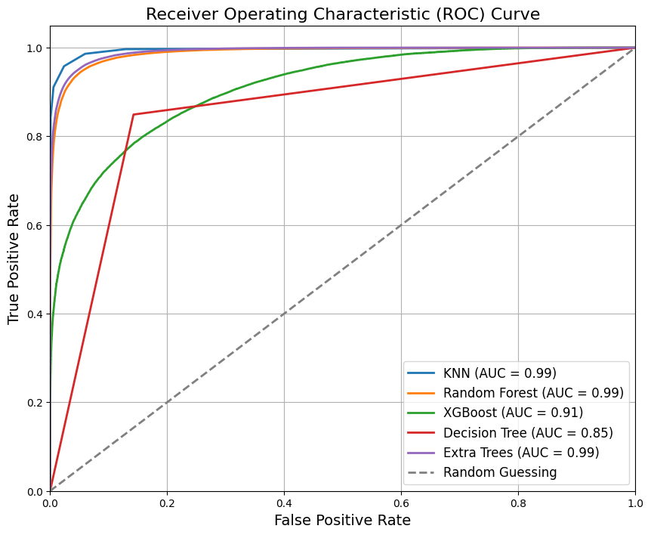

**Figure:** ROC Curve for Machine Learning Results using 8 Features with Feature Importance ≥ 0.70.

**Classification Reports – 8 Features**

**KNN:**

**precision recall f1-score support**

0 0.96 0.98 0.97 77676

1 0.98 0.96 0.97 77614

accuracy 0.97 155290

macro avg 0.97 0.97 0.97 155290

weighted avg 0.97 0.97 0.97 155290

**Random Forest:**

**precision recall f1-score support**

0 0.93 0.96 0.95 77676

1 0.96 0.93 0.94 77614

accuracy 0.94 155290

macro avg 0.95 0.94 0.94 155290

weighted avg 0.95 0.94 0.94 155290

**XGBoost:**

**precision recall f1-score support**

0 0.80 0.86 0.83 77676

1 0.84 0.79 0.81 77614

accuracy 0.82 155290

macro avg 0.82 0.82 0.82 155290

weighted avg 0.82 0.82 0.82 155290

**Decision Tree:**

**precision recall f1-score support**

0 0.85 0.86 0.85 77676

1 0.86 0.85 0.85 77614

accuracy 0.85 155290

macro avg 0.85 0.85 0.85 155290

weighted avg 0.85 0.85 0.85 155290

**Extra Trees:**

**precision recall f1-score support**

0 0.93 0.97 0.95 77676

1 0.97 0.92 0.95 77614

accuracy 0.95 155290

macro avg 0.95 0.95 0.95 155290

weighted avg 0.95 0.95 0.95 155290

**Confusion Matrix - 8 Features**

